# Scientific researchers on the catching method of birds

## Eurogroup for animals, 2020[1]

* When birds are carried by their legs (Figure 2.3), two behavioural responses are likely; either they will show tonic immobility (a reaction whereby they ‘freeze’ their behaviour and become immobile), or they will show a reaction indicative of stress or aversion, such as wing flapping (Wolff et al., 2019) and vocalisations. Tonic immobility is a natural response for chickens, usually a bird’s final response to the threat of a predator, although it can be misinterpreted to indicate a state of relaxation (McBride, 2017).
* Inverted shackling duration was also **positively associated with acute stress responses (corticosterone levels) and fearfulness, meaning that longer durations were associated with a greater stress response and more fear (Bedanova et al., 2007).**
* Another welfare issue associated with inverted handling is related to the big breast muscles of broilers belonging to fast-growing breeds compared to other types of chickens (e.g., slower-growing breeds, laying hens or jungle fowl). **Birds do not have a diaphragm and during inverted handling the pressure of the relatively heavy breast muscles of broiler chickens can burden their heart and lungs, which is likely uncomfortable and can be fatal. For the same reasons, so-called “turtle birds” – birds that end up lying on their back during grow-out/rearing or that were placed on their back in a transportation crate – will likely die if not turned onto their feet (Jacobs, 2016; Jacobs et al., 2017a).**
* In addition to stress, fear and aversion, rough treatment of broilers during catching can cause injuries such as bruising (Delezie et al., 2006), and fractures (0.8%, Kittelsen et al., 2015b). In one study, wing fracture prevalence increased from 0.1% to 1.9% after catching and loading compared to before (Jacobs, et al., 2017b). Bruising may be more frequent depending on the catching company involved, illustrating that some people may be rougher or differently trained than others (Nijdam et al., 2004, Jacobs et al., 2017b). Catching accounts for 11%-38% of bruises on breast, wings and legs (Reali, 1994, reported by Pilecco et al., 2013) and can cause back scratches, with flock prevalence of circa 15% (Pilecco et al., 2013).
* An older study concluded that catching and transportation injuries were the cause of 35% of pre-slaughter mortality, and 40% was due to stress or suffocation (Bayliss and Hinton, 1990). **More recent findings show that as many as 25% of DOA birds present some type of internal trauma, most commonly ruptured livers and fractures, which are likely the causes of death for those birds (Kittelsen et al., 2015a).** Injuries and mortality are a major concern for animal welfare and even low prevalence should be avoided as it is a major concern for the individual birds involved.
* Previous work has indicated that a person’s attitudes and beliefs affect their behaviour, thus, training to modify their beliefs and attitudes towards broiler chickens could theoretically change their catching behaviour. For example, people with positive beliefs about petting, verbal interaction and physical effort to handle cows, were less likely to show inappropriate behaviour such as pushes and hits when handling cows (Hemsworth et al., 2002). However, current industry training is more likely to involve skills-based aspects, including the transfer of technical knowledge (Coleman et al., 2000). **For other species, cognitive and behavioural modification training has proven effective for stock people (Hemsworth et al., 1994; Coleman et al., 2000; Hemsworth et al., 2002). Hemsworth et al. (1994) found the training to successfully improve worker attitudes and reduce fearfulness in pigs, with the pigs spending more time near the experimenter compared to control farms. In line with these findings, training for catching crews could be similarly beneficial for animal welfare parameters. One study found that skills-based training for catching crews for four consecutive weeks resulted in reduced incidence of back scratches (Pilecco et al., 2013).** Currently more research is needed on training of catching crews for better handling and the effects on broiler welfare. One limitation is that catching crews may not have a sense of ownership, which is more likely in stock people. Furthermore, labour turnaround, language and cultural differences could limit the effectiveness of training.
* **Alternative manual catching methods such as upright catching and abdomen catching (Kittelsen et al., 2018; Wolff et al., 2019)** have the potential to reduce welfare issues during the pre-slaughter phase. Using mechanical harvesters is economically feasible for some producers, but animal welfare outcomes do not always suggest improvements (more DOAs compared to manual catching; Ekstrand, 1998; Delezie et al., 2006; Chauvin et al., 2011) and further research is needed to determine best practices.

## Wolff, 2019[2]

* With regard to manual and mechanical catching techniques for the harvesting of poultry, the **Council of Europe issued a recommendation in 1995 stating that the birds must be lifted by holding both legs (not just one) and must not be held upside down (European Commission, 1995), which are contradictory demands. Instead of catching chicken by one or two legs and carrying them in an inverted position, the catcher should hold them under the abdomen and carry them in an upright position** (Kittelsen et al., 2018). However, in personal communication with poultry industry specialists, we learnt that more than two decades after the release of the recommendation, carrying of chicken in an inverted position and grabbing them by one leg are still common practice in manual harvesting (Anonymous, personal communication).
* Comparing the number of broilers carried at the same time, we found that the risk for wing flapping was highest when the catcher carried one broiler per hand. Possibly, these singly held broilers had more space for wing flapping and were not calmed down by the proximity of another broiler. **However, to reduce the risk for wing flapping, we recommend holding individual broilers under the abdomen instead of carrying several broilers in one hand at the same time. The abdomen technique is comparable with the UPRIGHT technique used by Kittelsen et al. (2018) and described as two birds being carried at once gently pressed together in an upright position, outer wing and chest embraced by the catcher’s hand.** This manual catching technique, which is known to be used in Sweden, is gentle to the birds and minimizes the risk of injuries (Knierim and Gocke, 2003). The advantages of the abdomen technique are that the broilers remain upright and are almost unable to flap their wings.
* **Based on plasma corticosterone concentrations, Kannan and Mench (1997) concluded that upright handling is less stressful to broilers than inverted carrying. The reduction of injuries and therefore of pain and stress for the broilers should enhance animal welfare during harvesting. In our study, the abdomen technique was only used by one catching team and only 24.0% of the broilers caught by the abdomen showed wing flapping, whereas an average of 74.0% showed wing flapping during the other manual harvesting techniques**

## EFSA, 2004[3]

* Trauma includes broken and dislocated bones, bruising and haemorrhages. In studies in one Member State, **3% of broilers had bones broken by poor handling between unloading from crates and stunning and 4.5% or more had dislocations. Broken bones caused by catching are more frequent in hens at end of lay, in which prevalences of 13-41% with a mean of 24% have been recorded in several studies.**
* Nearly 80% of bruising in turkeys has been found to take place within the last 12 to 24 h of the birds’ lives as a consequence of handling and transport.
* A high proportion of commercial broilers show some degree of lameness caused by problems in the bones and joints of the legs (Julian, 1984; Kestin et al., 1992; Kestin et al, 2001; Sanotra et al.,2001). The aetiology and pathology of the condition have been reviewed by Bradshaw et al. (2002). Lameness is likely to be painful (McGeown et al, 1999; Danbury et al, 2000) and transport, and the handling associated with it, is likely to increase the suffering of these birds. The case of lame broiler chickens presents particular concerns with regard to their not being transported in order to avoid increased suffering.
* Catching hens in “alternative” systems such as percheries is often made difficult by the furniture and structure associated with the perches and nest boxes, and the fact that birds have more opportunity to escape. **Both cages and alternative systems should therefore be designed with bird depopulation in mind since easy catching is likely to be less stressful to the birds and result in less physical trauma.**

## Kittelsen, 2018

* “The results showed that the abdominal and upright method was faster and gave a lower and more consistent number of birds per drawer. In addition, this method tended towards fewer wing fractures. No broken legs, birds on their back in the drawers or broilers dead-on-arrival were observed in the study. Catching is a critical phase in the pre-slaughter chain, and this study shows that the catching and carrying method affects broiler welfare.”

## Temple Grandin, 2014[4]

* *“A direct comparison of different catching and carrying methods for end-of lay hens showed that* ***plasma corticosterone concentrations were significantly higher when they were removed from their cages three at a time and carried in an inverted position from the house, than when they were removed singly and crated before removal from the house (Knowles and Broom, 1993)****. However,* ***all hens in experimental handling treatments had high concentrations of corticosterone in comparison with control birds that were removed individually and gently from their cages in an upright position*** *(Knowles and Broom, 1993), Scott and Moran (1993) found that the fear levels of laying hens caried for 20m on a flat conveyer were lower than those of hens carried the same distance in an inverted position by hand or on a processing shackle, although in the absence of a non-iverted control in this study, it is difficult to know wheter the recuded fear was a consequence of upright conveyance or some other fear reducing property of the flatbed conveyer.”*

## WUR “Kip, ik heb je”, 2009[5]

* “*De Zweedse vangmethode geeft t.o.v. een vangmachine 0,02% minder breuken en 0,014% minder kneuzingen voor 9 eurocent extra per kuiken.”*
* *“Uitkomsten van studies naar machinaal vangen zijn afhankelijk van de gebruikte afstellingen van de vangmachine zoals vangsnelheid. Een hoge vangsnelheid kan meer verwondingen tot gevolg hebben (Mennen, pers. med. 2008). Dit wordt geïllustreerd door een lager percentage kneuzingen en breuken gevonden door Ekstrand (1998) vergeleken met de andere drie vergelijkende studies.* ***Ekstrand (1998) liet ook zien dat de Zweedse manier van vangen de minste vangschade geeft. Een rustige manier van vleeskuikens oppakken met niet meer dan twee tegelijk is in ieder geval voor de dieren de beste methode.”***

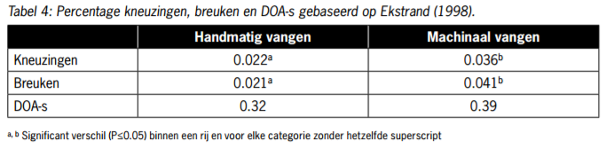

* *“De Zweedse vangmethode is zoals verwacht fors duurder dan de overige vangmethoden. Deze kostenstijging wordt primair door een verlaging van de vangsnelheid en de hiermee gepaard gaande stijging van de arbeidskosten veroorzaakt.* ***Tegenover deze kostenstijging staat de studie van Ekstrand (1998) waarin een lager percentage verwondingen wordt aangetoond ten opzichte van machinaal vangen.*** *In het huidige systeem vindt geen uitbetaling naar kwaliteit plaats, in de huidige situatie bestaat dus geen directe financiële compensatie voor een kwaliteitsverbetering. Uitbetaling naar kwaliteit biedt kansen voor de toekomst.”*
* *“Voor het welzijn van de vleeskuikens is de Zweedse methode om kuikens te vangen te prefereren boven de vangmachine en de traditionele manier van vangen.”*

## Ekstrand, 1998[6]

* *“In some cases, the catcher takes a bird around the body and uses both hands to hold a pair of birds upright on the way to the crates (Gerrits et al 1985). This way of catching the birds, which has been widely used in Sweden for several years, is recommended in order to reduce the risk of injuring the birds and subsequent downgrading of the meat (Parry 1989) and requires gentle handling of the birds during catching, loading, transport and unloading (Berry et a11990). Manual catching may result in low levels of injuries if all catchers are careful. conscientious and well-supervised (Kettlewell & Turner 1985; Berry et aI1990).”*
* *“If the birds are dropped into the crates or modules from any height they are likely to sustain wing injuries as they wing-flap during the fall (Duncan 1989).”*

## Knowles and Broom, 1993[7]

* *“In the second trial there was a trend for the birds pulled from the cage in groups of three to have higher plasma corticosterone concentrations than the birds which were removed individually.”*
* *“Their work showed that catching and removing birds from the cage one at a time by both legs resulted in the lowest incidence of broken bones (4·6 per cent of birds), removing one bird at a time by one leg resulted in 13·8 per cent of breaks, and removing three birds at a time by one leg resulted in 10·8 per cent.”*

## Knowles and Broom, 1990[8]

* *“Broom et al. (1986, unpublished data, 1990) compared normal handling of spent hens with gentle handling (Fig. 1 ). The hens were carried for 90 s either in the normal inverted manner or gently in an upright position. They were then blood sampled or placed in a crate 2 min after removal from the cage. Those crated were removed and blood sampled at 5 or 30 min after removal from the cage. No bird was blood sampled twice.* ***The plasma corticosterone levels of birds handled gently were consistently lower than those handled commercially and had returned to pre-catch levels within 30 min.”***

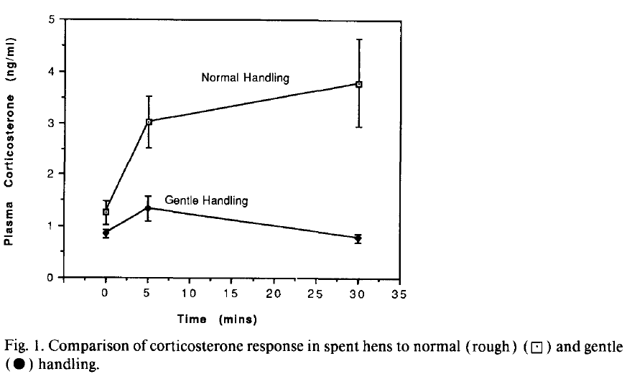

* *“Broom et al. ( 1986, unpublished data, 1990) in an experiment to compare the effects of handling, handling and crating, and handling, crating and transport found no difference in plasma corticosterone levels between groups of hens that were removed from their cages and left stationary in crates for 2 h and hens removed from their cages, crated and transported in an enclosed van for 2 h (Table 3).* ***The response after handling was much greater than that at the end of transport.*** *This suggests that the handling component of transportation has the greatest effect on spent hens and that being crated and driven on a vehicle has the same effect as crating alone. The latter finding is in agreement with the findings of Duncan and Kite (1987 ) in broilers. Broilers subjected to crating and then to a 40-min bumpy vehicle ride at 20 km h- or crating and 40 min left stationary showed no differences between the two treatments in the indices measured. Both treatments resulted in differences in indices from control birds.”*

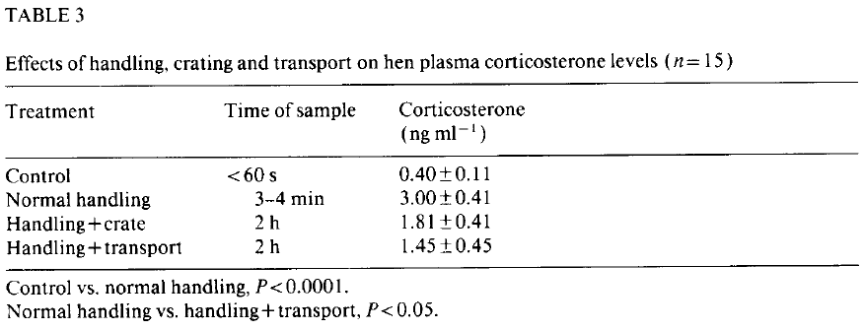

* ***“Handling appears to be the most traumatic part of the procedure and, as well as eliciting a considerable emergency reaction, it is the cause of high levels of bone breakage. The problems have been shown to be reduced by slower, gentler handling.*** *They are exacerbated by poor cage design but the methods used by the catching gangs, who are encouraged to deplete hen houses very quickly, are the major causes of the very poor welfare. Recent research, especially that into the number of broken bones, indicates that there is much unnecessary suffering, and that it is avoidable.”*

## Broom et al, 1986[9]

* *“Normal” handling, involving carrying two birds in each hand by their legs for 60 s, resulted in much higher plasma corticosterone levels than gentle, careful handling.”*

# Bio-rhythm

## Ekstrand, 1998[10]

* *“Experiments on the effects of light intensity during catching, have shown that the birds are calmer and less affected by the catching process if they are handled in darkness (Duncan 1989).”*

## Knowles and Broom, 1990[11]

* *“During catching and handling, birds display escape responses which increase the likelihood of damage to themselves. A practical method of subduing the birds is thought to be a reduced light level. This method is employed by many broiler transporters. In an experiment using caged spent hens handled in a commercial manner in two light levels (Table 2) there was a trend for birds handled in the lighter conditions to show a longer duration of TI (T.G. Knowles, unpublished data, 1990).Duncan and Kite (1987) found a more marked difference between the effects of a bright and a dim light on broiler response to handling. Manual carrying was compared with mechanical herding and conveying, both in dark (0.35 Ix ) and in light (88 lx ) conditions. They also tried to establish whether the effects of different treatments were additive. Manual carrying had a greater effect on the broilers than the mechanical herding and conveying and both treatments had less effect when carried out in the dark. The light/dark treatments had more effect than the manual/mechanical treatments.”*

# Sources

1. https://www.eurogroupforanimals.org/files/eurogroupforanimals/2020-11/2020_11_19_eurogroup_for_animals_broiler_report.pdf
2. https://reader.elsevier.com/reader/sd/pii/S0168159119301376?token=CF21F5C781F400B252A54C7FBDD673D535BCBEE0A59DA0159B638DC65C64457D2F99C994D67DBD98E00B1BEDE7FA9E8D&originRegion=eu-west-1&originCreation=20211222092812
3. (2004) Opinion of the Scientific Panel on Animal Health and Welfare on a request from the

   Commission related to the welfare of animals during transport
4. Grandin, T. (2014) Livestock handling and transport 4th edition. Online: http://bit.ly/2rI2Rk7
5. Eilers et al (2009), Kip ik heb je
6. Ekstrand, C (1998) AN OBSERVATIONAL COHORT STUDY OF THE EFFECTS OF CATCHING METHOD ON CARCASE

   REJECTION RATES IN BROILERS
7. Knowles and Broom (1993) Effect of catching method on the concentration of plasma corticosterone in end-of-lay battery hens
8. Knowles and Broom (1990) The handling and transport of broilers and spent hens
9. Broom et al (1986) Hen behaviour and hypothalamic –putuitary-adrenal responses to handling and transport
10. Ekstrand, C (1998) AN OBSERVATIONAL COHORT STUDY OF THE EFFECTS OF CATCHING METHOD ON CARCASE

    REJECTION RATES IN BROILERS
11. Knowles and Broom (1990) The handling and transport of broilers and spent hens